


University of Baltistan Skardu

Public College Skardu
Department of Computer Science

“Patient Management System”
Course: Data Structure & Algorithm

By:
Mr. SOHAIL-2024-uobsac-1362
Mr. WILAYAT ALI-2024-uobsac-1407
Mr. WAQAR AHMED-2024-uobsac-1367
Mr. SHABBIR HUSSAIN-2024-uobsac-1361

Submitted to: Mr. Sajid Ali
Date: 11-10-2025

Table of content:
1. Introduction 2
2. Problem Statement 2
3. Objectives 2
4. Tools and Technologies 3
5. System Overview 3
6. System Architecture Diagram 3
7. Data Structures Used 4
8. Algorithm Design 4
9. System Workflow Diagram 5
10. Expected Output 6
11. Advantages 6
12. Conclusion 6
13. Future Enhancements 6
14. Reference 7

1. Introduction
The Hospital Patient Management System is a comprehensive Python-based application designed to streamline and automate various hospital operations, ensuring efficient management of patient information and administrative tasks. In modern healthcare institutions, managing a large volume of patient data manually can lead to errors, inefficiency, and time delays. This project addresses these challenges by implementing a computerized system that integrates core hospital processes such as patient registration, appointment scheduling, medical record management, and billing operations.
This system serves as a practical demonstration of the application of Data Structures and Algorithms (DSA) in real-world problem solving. It utilizes essential data structures including arrays, linked lists, stacks, queues, and trees to organize, store, and retrieve information effectively. Each data structure plays a vital role in different modules of the system—for instance, queues are used for managing patient appointments in order of arrival, linked lists are employed for dynamic record management, and trees are utilized for efficient searching and sorting of patient records.

2. Problem Statement
Hospitals handle a large volume of patient data daily. Manual handling often causes inefficiencies and errors. This project addresses these issues by providing an automated system that leverages efficient data structures for accuracy, speed, and scalability.

3. Objectives

The main objectives of this project are to apply Data Structures and Algorithms (DSA) concepts in real-world healthcare systems and to develop an efficient patient record management system. The project focuses on implementing optimized search, insert, and update algorithms to ensure fast and accurate data processing. Additionally, it aims to enhance the understanding of time and space complexity trade-offs, allowing for better analysis and selection of algorithms and data structures for efficient system performance.

4. Tools and Technologies
Tools and Technologies:
Tool/Technology | Purpose
Python | Core programming language
Flask | Graphical User Interface
CSV / SQLite3 | Data storage
VS Code / PyCharm | Development environment
Draw.io / Graphviz | System diagrams

5. System Overview
The system enables staff to perform patient registration, appointment scheduling, searching, updating, and billing operations using efficient data structures.

6. System Architecture Diagram
Conceptual design of the system:
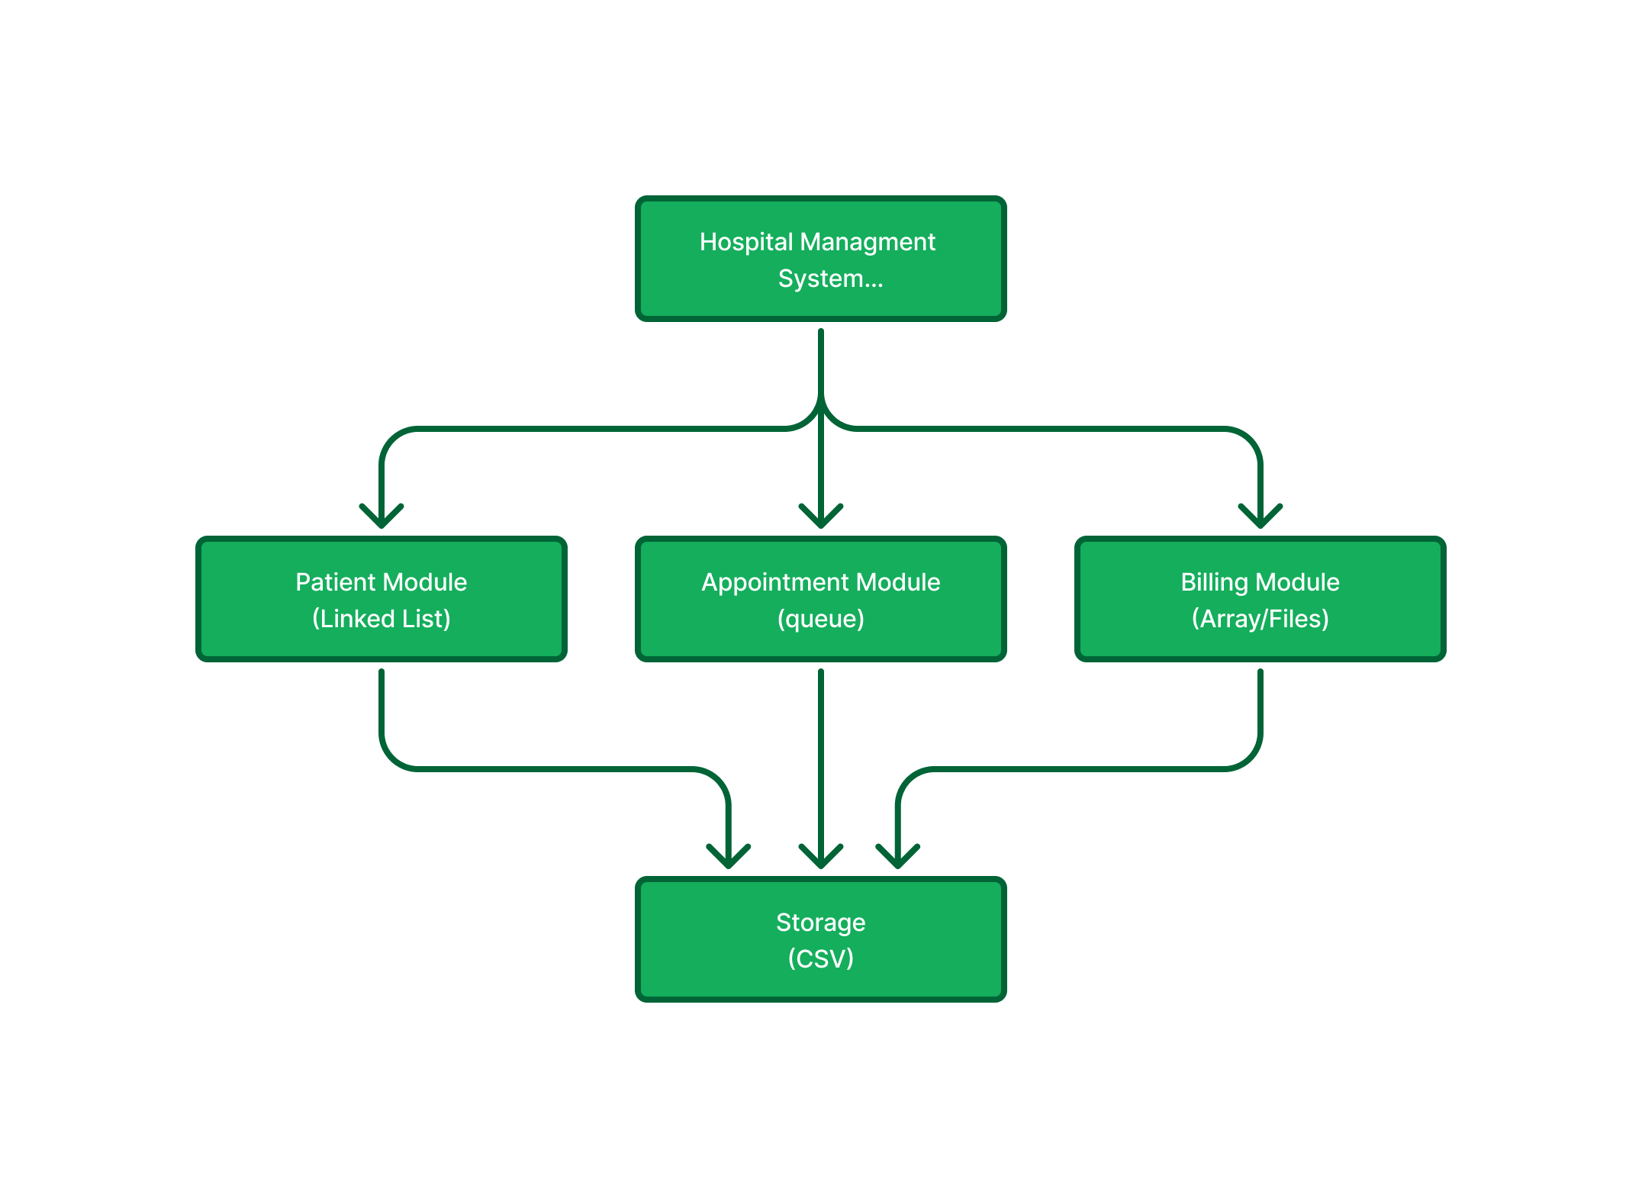
Figure no: 1

7. Data Structures Used
Data Structures Used:
Data Structure | Use Case
List / Array | Store and access general patient data quickly.
Linked List | Manage dynamic patient records efficiently.
Queue | Maintain patient appointments in FIFO order.
Stack | Handle undo/delete operations (LIFO).
Tree | Categorize patients by department or doctor.

8. Algorithm Design
Example implementations of algorithms:
- Patient Registration (Linked List)
Each patient node contains: PatientID, Name, Age, Disease, and DoctorAssigned.
Pseudocode:
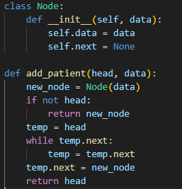
Appointment Queue (FIFO)
Figure 2
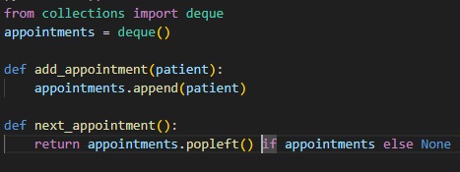
Figure no: 3

9. System Workflow Diagram
Flow of operations:
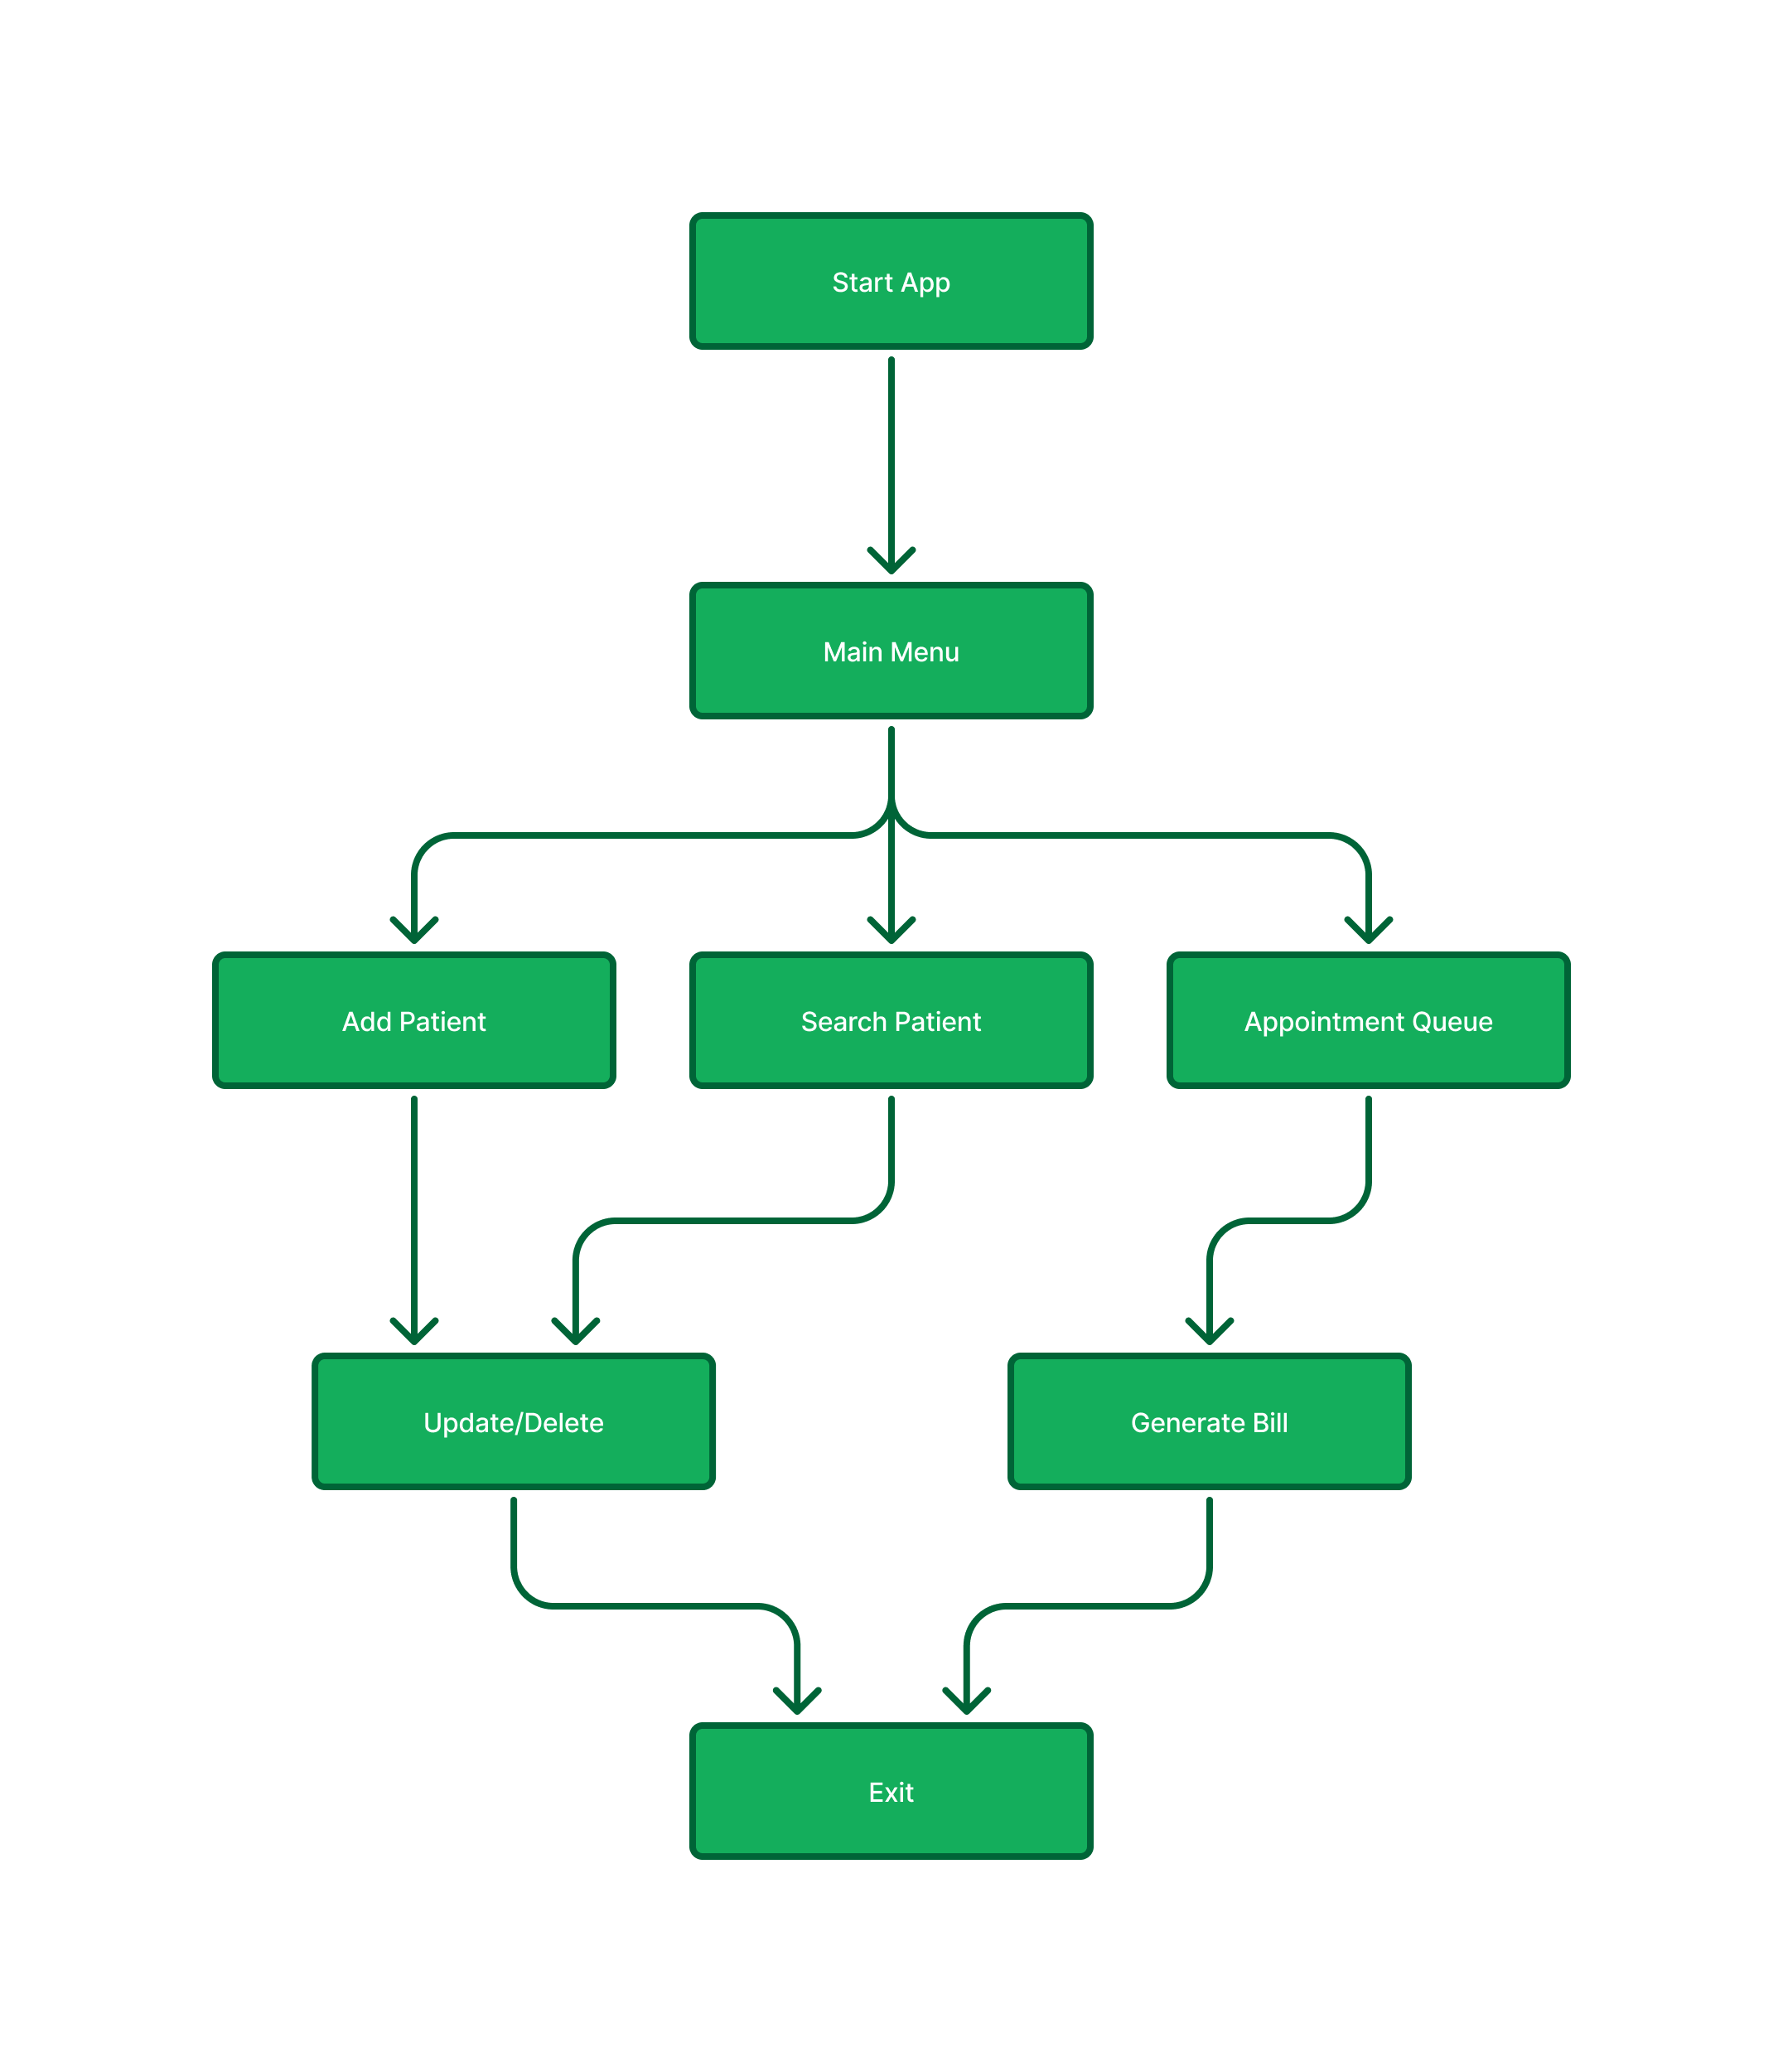
Figure no: 4

10. Expected Output
The expected output of this project includes fast data access through the implementation of efficient search algorithms, ensuring quick retrieval of patient records and information. The system is also designed to provide efficient queue handling for managing patient appointments in an organized manner. Additionally, it allows easy update and delete operations to maintain accurate and up-to-date patient data. Overall, the project aims to achieve real-time data management, enhancing the speed, reliability, and effectiveness of hospital operations.

11. Advantages

The proposed system offers several advantages, including a significant reduction in manual errors by automating hospital management tasks. It saves time through automation, allowing faster and more efficient handling of patient data and hospital operations. The project also demonstrates a clear understanding of Data Structures and Algorithms (DSA) by applying theoretical concepts to practical scenarios. Moreover, the system is designed to be scalable, providing flexibility for future improvements and enhancements as hospital requirements grow or new technologies emerge.

12. Conclusion
The Hospital Patient Management System demonstrates the power of Data Structures and Algorithms in real-world problem solving. By integrating linked lists, queues, stacks, and trees, this project enhances efficiency, accuracy, and scalability within hospital operations.

13. Future Enhancements
In the future, the system can be enhanced by adding a Graphical User Interface (GUI) using frameworks such as Tkinter or PyQt to make it more interactive and user-friendly. A database system like SQLite3 can be integrated for persistent data storage, ensuring that patient and hospital records are securely saved and easily retrievable. Additionally, a priority queue mechanism can be implemented to efficiently handle emergency cases, ensuring that critical patients receive immediate attention. Another important enhancement is the addition of authentication features for doctors and staff to maintain data security and control access to sensitive hospital information.

14. Reference

1.Sharma, R., & Gupta, A. (2022). Design and Implementation of a Hospital Patient Management System Using Data Structures and Databases. International Journal of Computer Applications, 184(25), 15–21. https://doi.org/10.5120/ijca2022922513
2. Patel, M., & Singh, K. (2021). A Queue-Based Appointment Scheduling Algorithm for Hospital Management Systems. Journal of Computer Science and Information Technology, 9(3), 45–52.
3. Chen, L., & Ahmed, S. (2023). Efficient Data Storage and Retrieval in Healthcare Systems Using SQLite and CSV Integration. International Journal of Advanced Computer Science and Applications, 14(7), 110–118.

